

SCSV 2113
HUMAN COMPUTER INTERACTION
(Session 2018/2019 Semester 1)
Project part IV – Paper Prototyping User testing
Submitted to
NOR ANITA FAIROS BINTI ISMAIL
Submitted By
Group -5 (HalfLifeConfirmedYet)

Miraj Ahmed (A16CS4017)
Nazmus Sakib (A17CS0265)
Mohana Raj a/l Shanmugam (A15CS0067)
Wa’ad Shaher (A17CS0288)

Snaps from the Prototype :
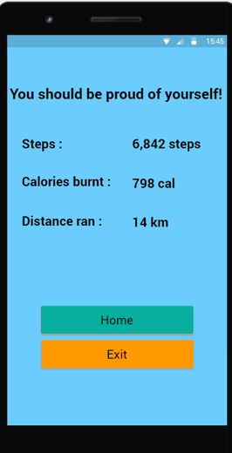
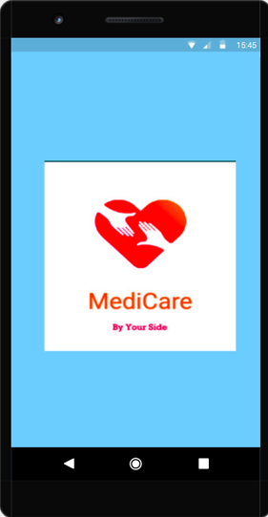

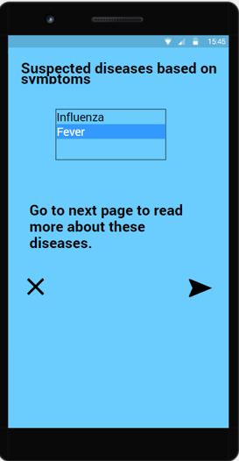
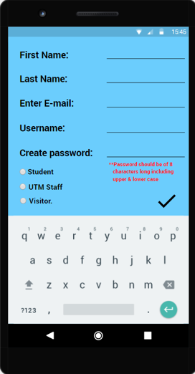

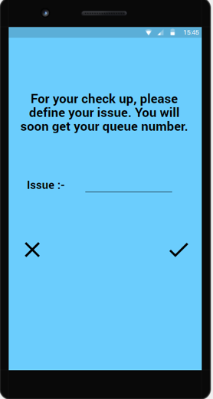
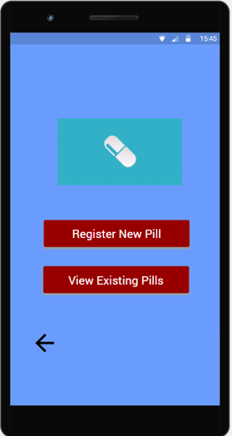

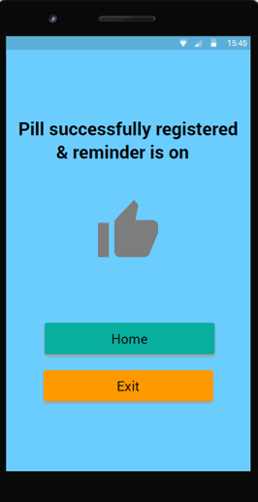
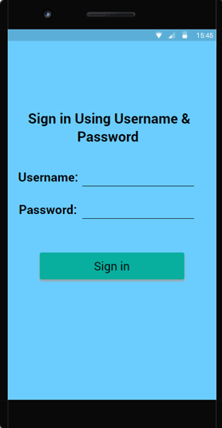

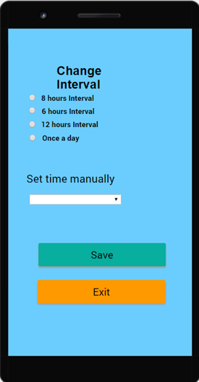
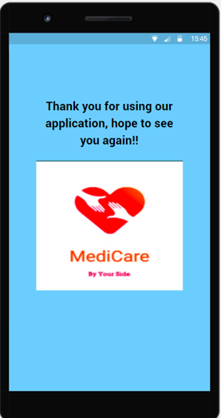

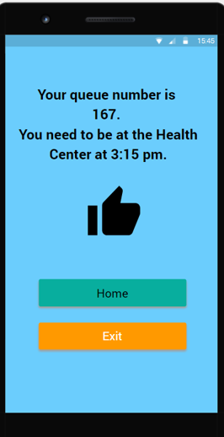

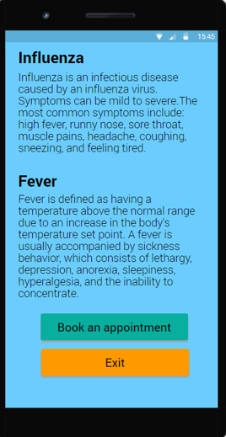

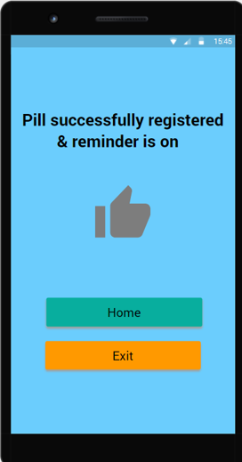
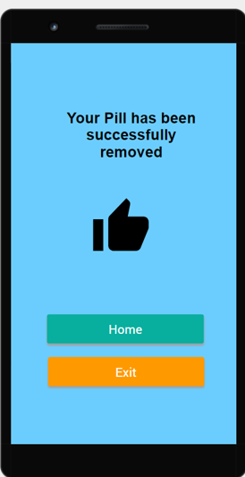
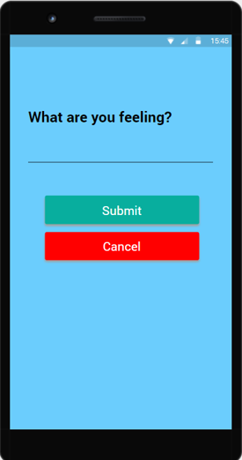
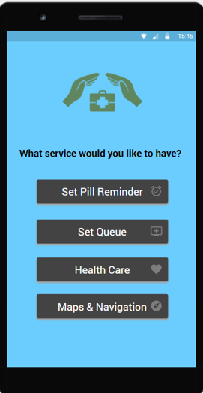
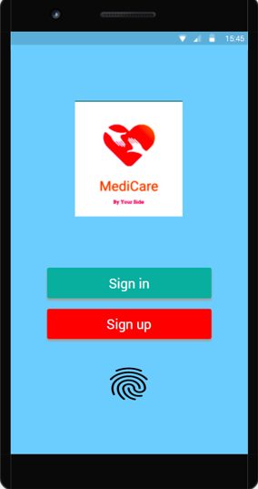
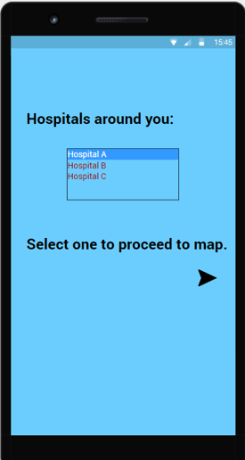
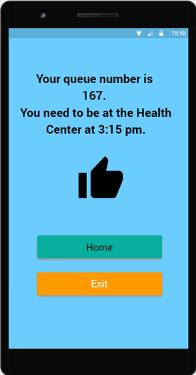
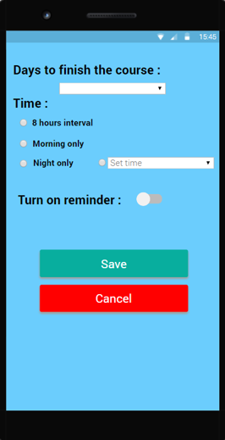
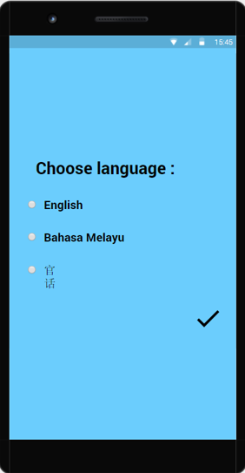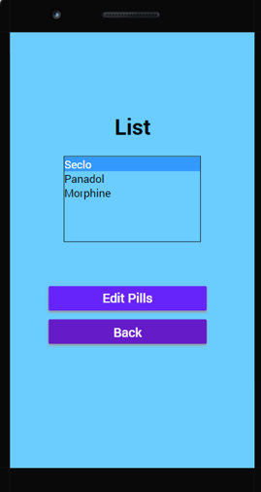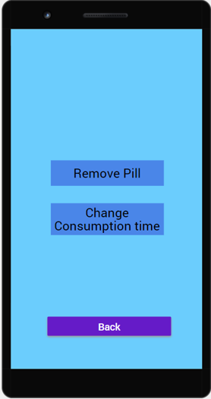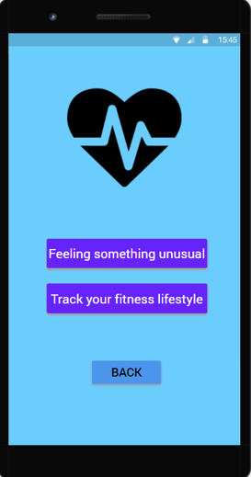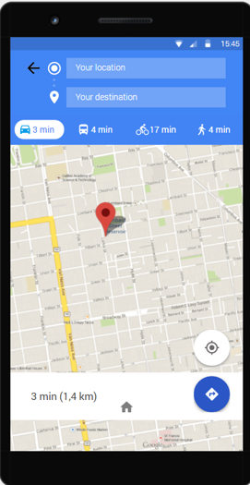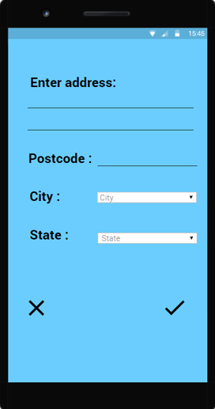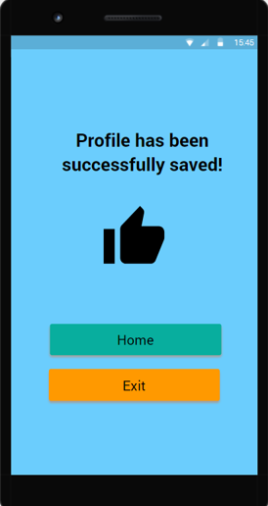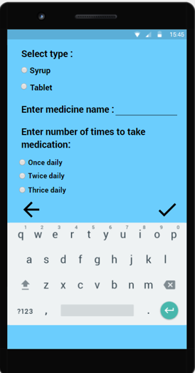

Task1 – set pill reminder
-user has to set a reminder for his/her desired pill
-user can edit and also delete the reminder he/she set for certain pill.
Task 2 – set queue
-user have to sign in to proceed
-user can register for queue in hospital through the app.
-user will get notification regarding his queue number .

Task 3 – Health Care
-user can also identify his/her sickness
-user have to insert some basic terms regarding his/her feeling
-user will get some similar guesses about his sickness, which can make easier to tell the doctor.
Task 4- Maps and navigation
-user can track down the nearest hospital through the app.
-user will also get the navigation towards the hospital.

Scenario Tasks :
Before proceeding with the app , the user needs to sign up if it is his/her first time , then login to proceed.
User goal : Pill Reminder
- Select the desired button from the screen, set reminder or see the existing.
- In set reminder need to input the pill name , how many times in a day and the period.
- In existing pill , can delete the finished course , or edit as per doctor’s prescription.
User Goal : Set Queue
- Enter the set queue option.
- Input the issues the patient is having.
- Automatically will generate a form relating the queue number and calling time.

User Goal: Health Care
- Get an idea about physical sickness , also directed to set appointment.
- Track fitness on a basis routine.
User Goal : Maps and Navigation
- Input the place or use GPS to get the nearest desired hospital.
- Get the navigation towards the hospital.

User Demographics :
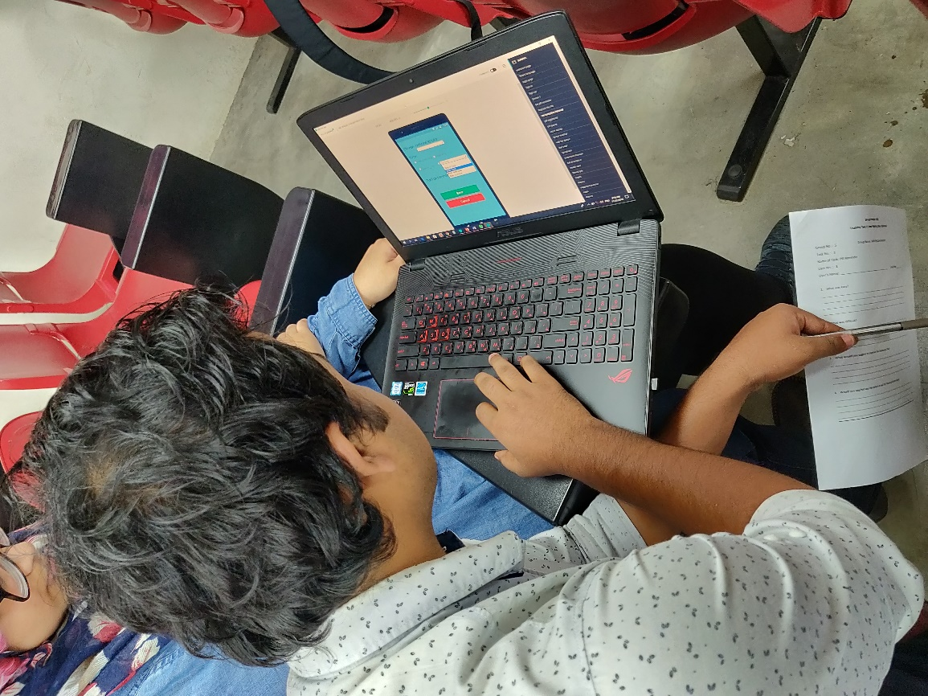
User 1 : Emrul Kayser Evan

User 2 : Muhammad Haziq Bin Amir.
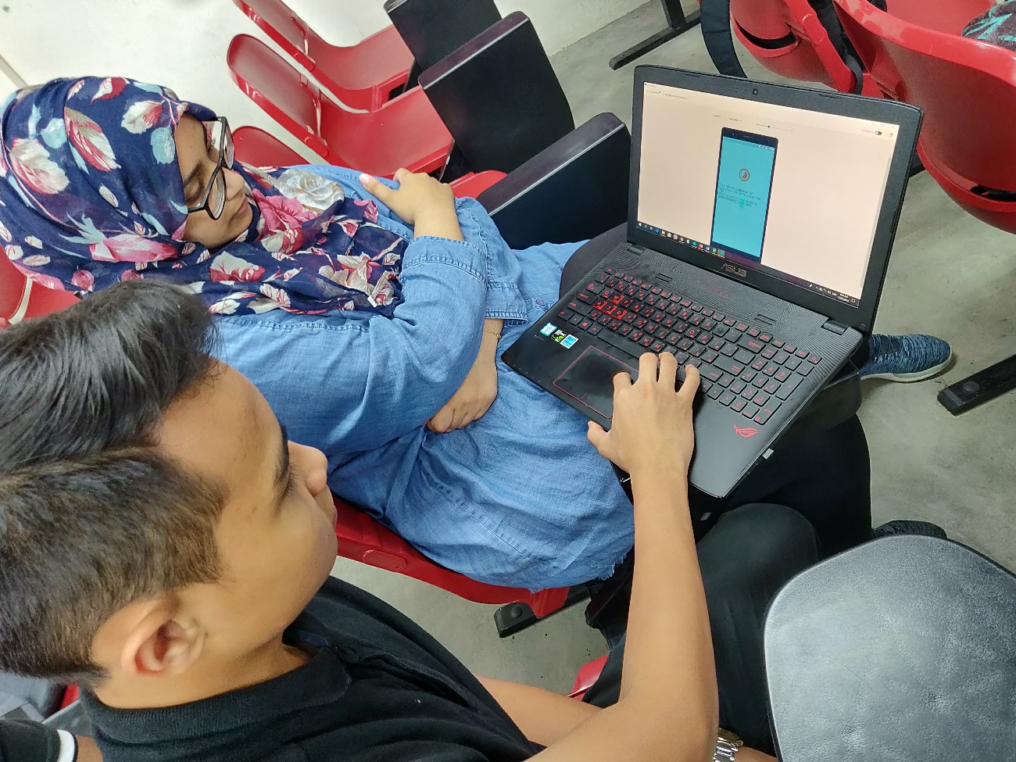

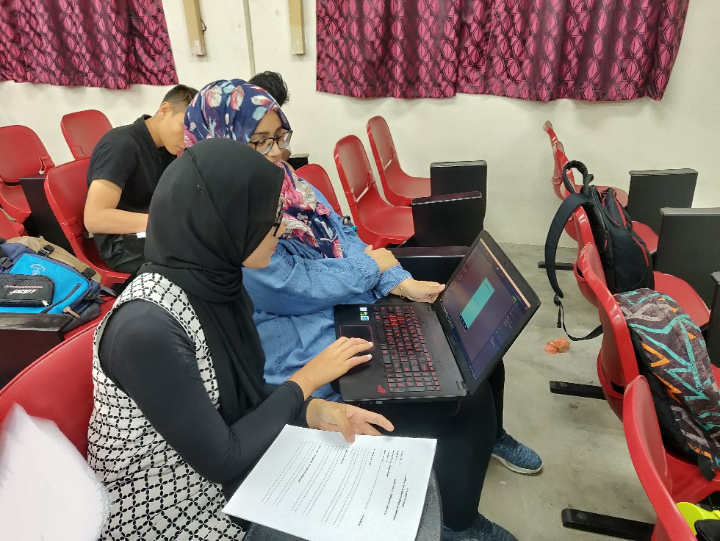
User 3: Nurhasnatul Aida

Our Respected lecturer , testing the pros and cons of the prototype and helping us how can we improve it.
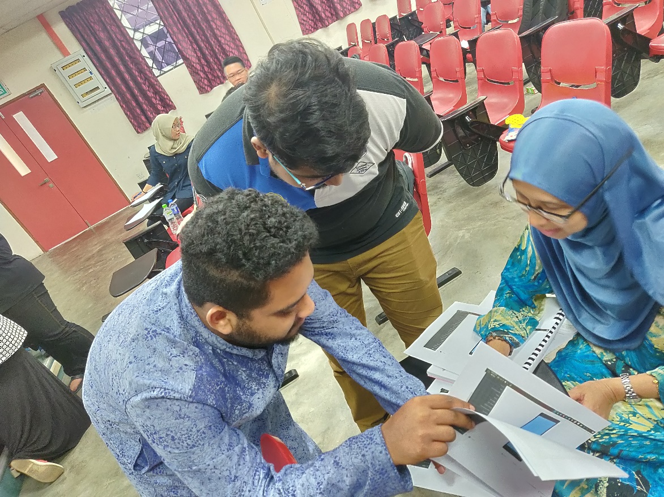
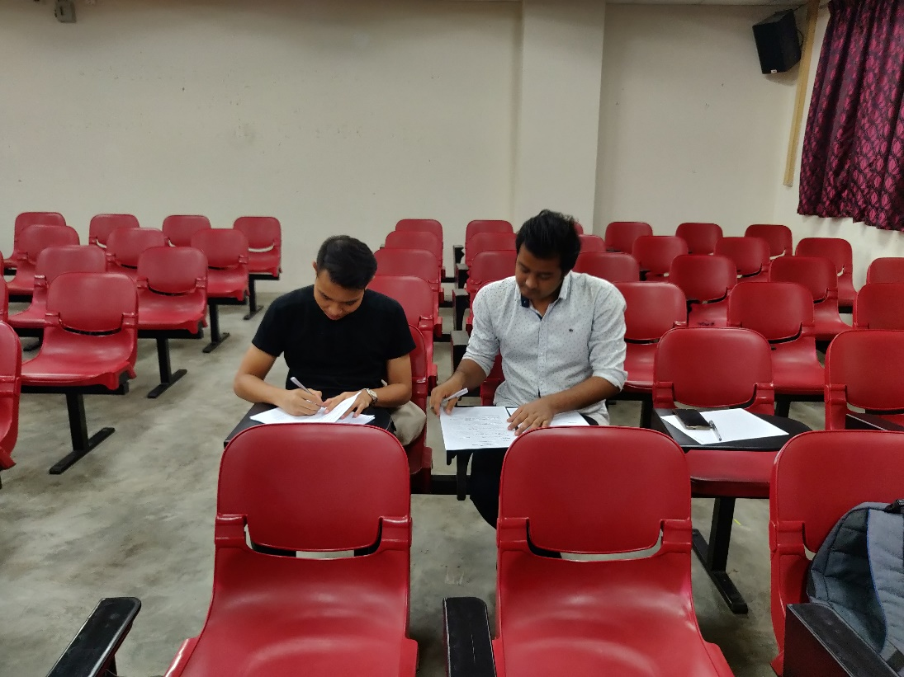
User giving their thoughts about the prototype.

Observations :
For task 1, there was no button to edit the reminder user needs to edit about the course after finish or missing.
For task 2, User could not trust the sources of directing the page set queue without updating any issues.
For task 3, user needed drop down options, symptoms can be more than one diseases .
For task 4, user felt complicated about the system, need to simplify.

Feedback from users :
User 1
Task 1 : Felt easy to set reminder, though suggested to use actual time in number instead of period.
Task 2 : felts easy to set queue, though suggested to use matric instead of ACID.
Task 3 : Suggested to add daily diet routine .
Task 4 : loved the feature though faced difficulty setting the map.
User 2
Task 1 : user found its easy and helpful to set the reminder, though user suggested to add delete button to the task.
Task 2 : user found the task is bit complicated, though the user liked the easy queue system.
Task 3 : user liked this task, suggested to keep it as it is.
Task 4 : user suggested to add doctor location to the task.

User 3
Task 1: User liked the feature, though suggested us to remove login for this task as it is normal alarm type.
Task 2: User liked the queue set up as she can focus on other task while setting the queue, though she wanted the current number going on the board.
Task 3 : User found distressing about login , she commented on the limitation of the database , suggested to update the database to get symptoms.
Task 4 : She loved the feature it is kind of time saving and helpful.

User 4
User felt the system too complicated so suggested to simplify the system first and remove some of the features and add few features.

NB : the whole file about user testing is uploaded to a drive and the link is being given in our blog .

