
SCSV 2113
HUMAN COMPUTER INTERACTION
(Session 2018/2019 Semester 1)
Project part III – Conceptual and Physical Design

Submitted to
NOR ANITA FAIROS BINTI ISMAIL
Submitted By
Group -5 (HalfLifeConfirmedYet)
Miraj Ahmed (A16CS4017)
Nazmus Sakib (A17CS0265)
Mohana Raj a/l Shanmugam (A15CS0067)
Wa’ad Shaher (A17CS0288)
Interaction Metaphors

What is metaphor ?
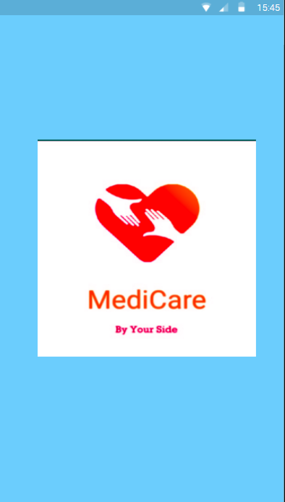
A metaphor is an analogy, e.g. a picture, symbol or concept, that we use to make interaction simpler and more intuitive. In the user interface, we give information and operations a physical (graphical) appearance. The idea is to create images that facilitate the user's understanding, learning, performance, information organization, etc. Metaphors are used on different levels, e.g. as a basic building block or as a principle for grouping information on the screen.

Advantages :
Advantage of using metaphors in HCI design is to utilize and extend the concepts that already exist in computer users' long-term memory, to analog represent the functions and operations of the computer systems and reduce the users' mental workload. Therefore, the efficiency of an HCI and the usability of a computer system may largely determined by the appropriateness of the metaphors used. This study collected and analyzed a number of existing HCI metaphors and developed guidelines for determining basic metaphors that should be used in the design of HCI to maximize the intelligibility and minimize the intended users' mental workload. As a conclusion, basic metaphors should have four important properties:
(1) The source of basic metaphors must be from the intended users' knowledge domain.
(2) The intelligibility of visual metaphors determines the correctness of the user's responses.
(3) The operational features of metaphorical components should be the same as those of metaphor sources.
(4) The metaphors used in a specific human-computer interface should be of the same conceptual domain.

Our Metaphors :
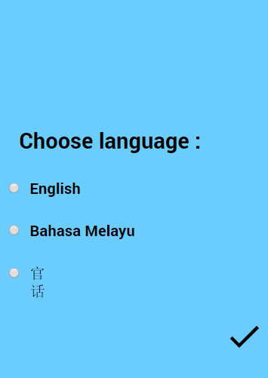
For our app “Medicare-By your side” we used few of the HCI based interactions which are given below :
– Simple Language choices .
– All has a graphical form, represented as pictures
(icons, windows, buttons, scroll bars etc…..)
– A menu driven function to get the desired options by pulling out or popping in.

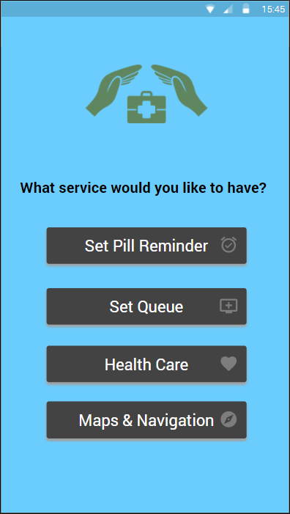
– WYSIWYG(what you see is what you get) approach is included.
– The user manipulates the objects by clicking or by short commands.
– Based on recognition (ie.login).
– The dialogues are even driver (ie. You are having fever, your queue number is granted)

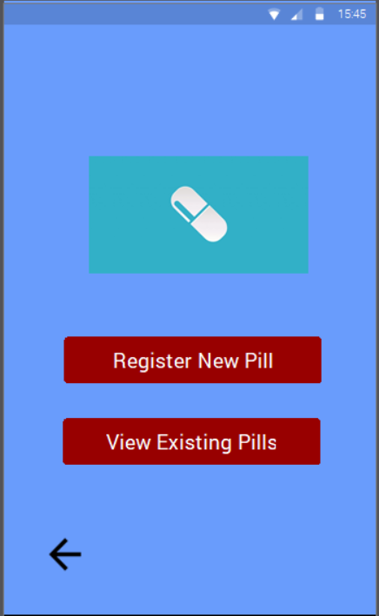

- The user will know what this page is for through the graphical inefaces.
- The colors are set to red cause they will know it is something crucial as it is about the pills.

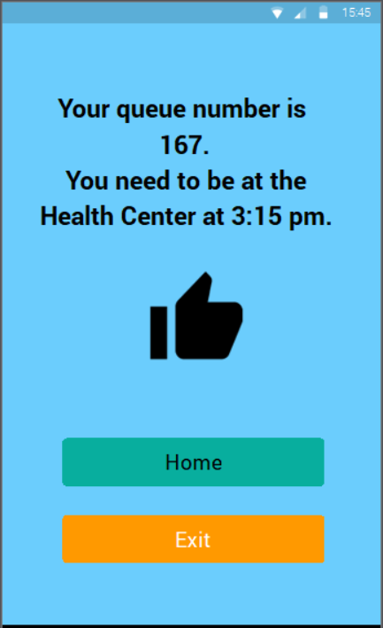

- The thumbs up sign will user know that his or her queue is successfully entered.
- The yellow colour is to indicate that button will exit the app.

Story Boarding :
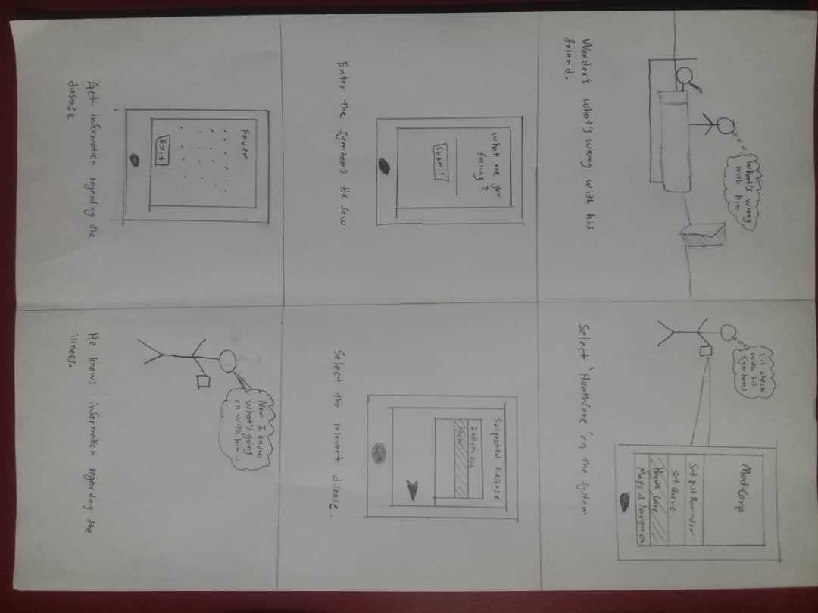
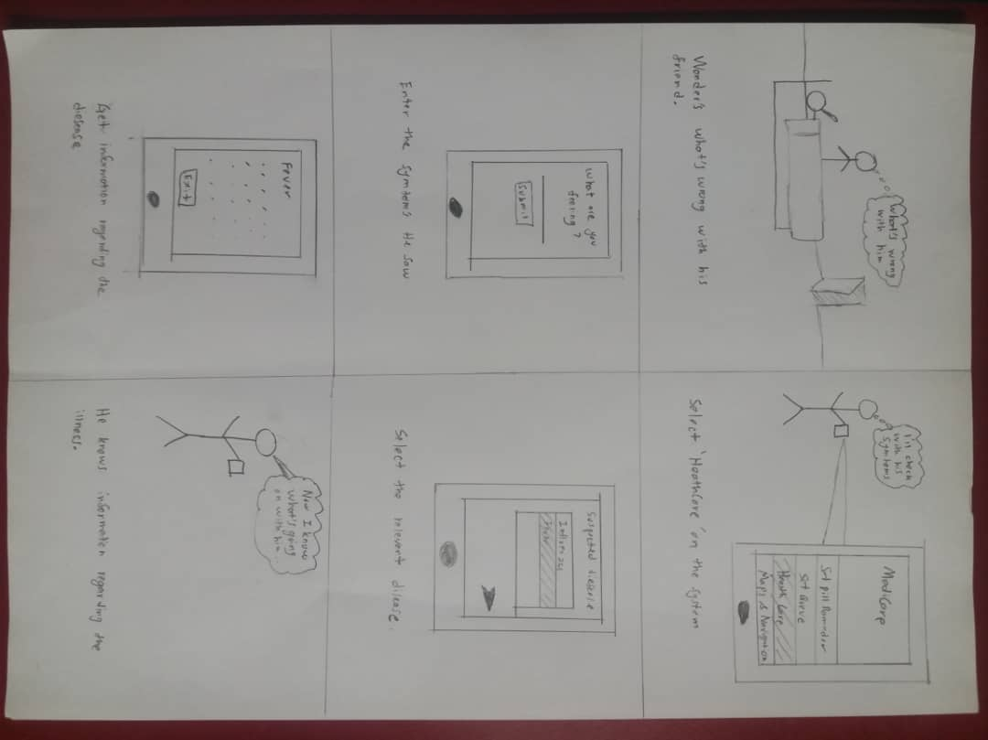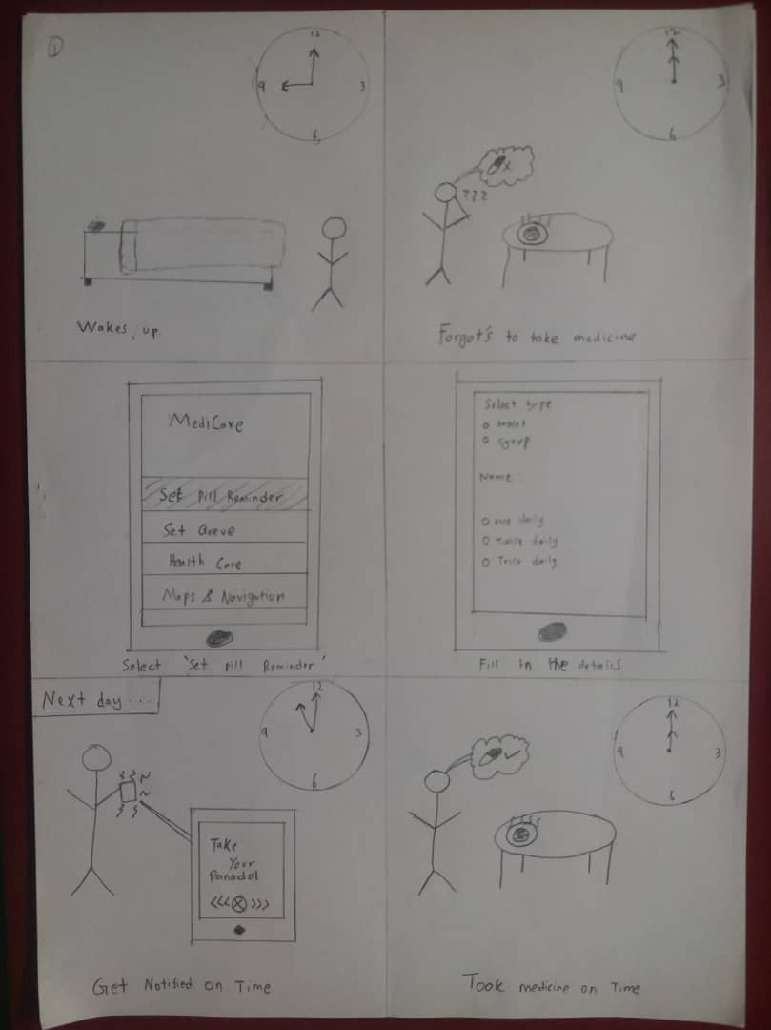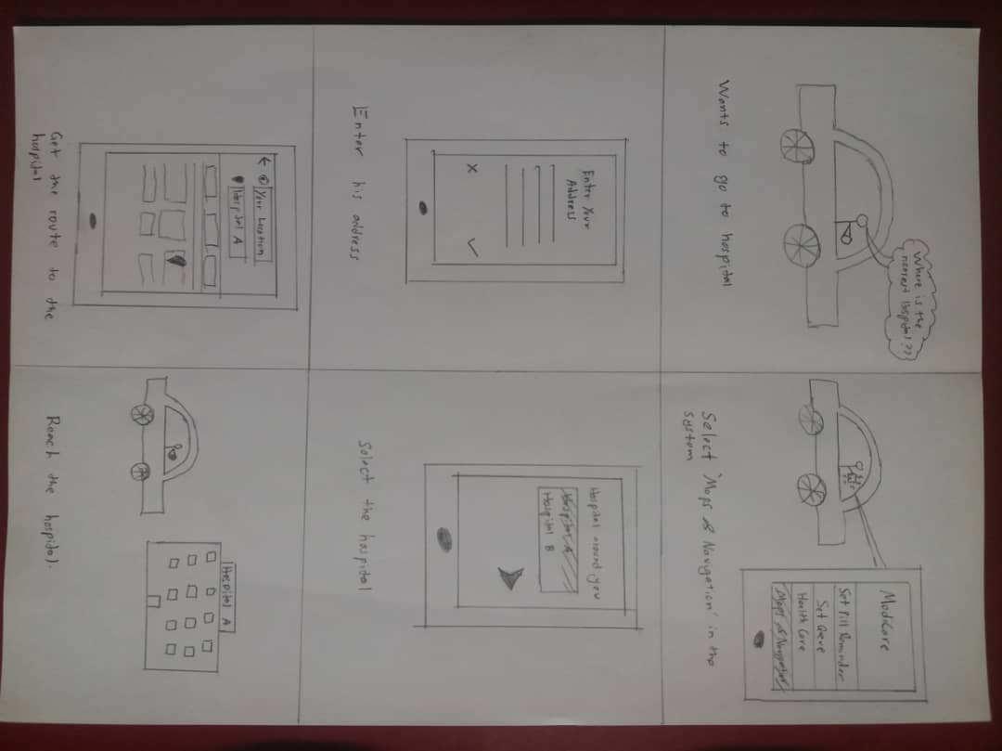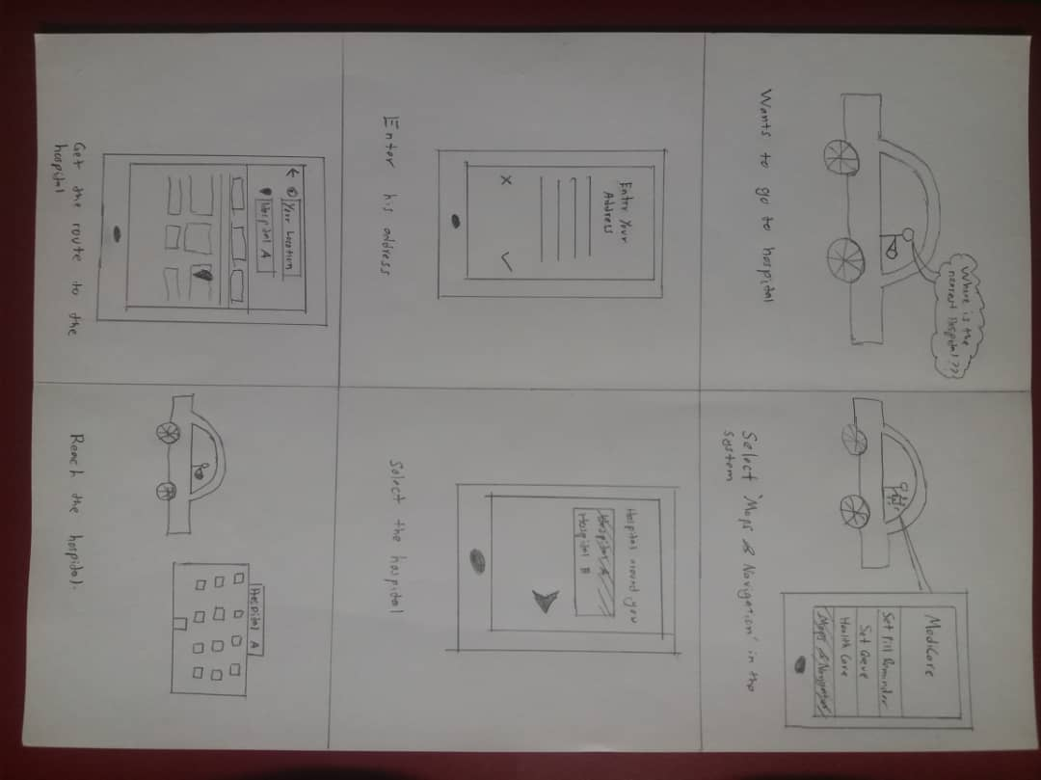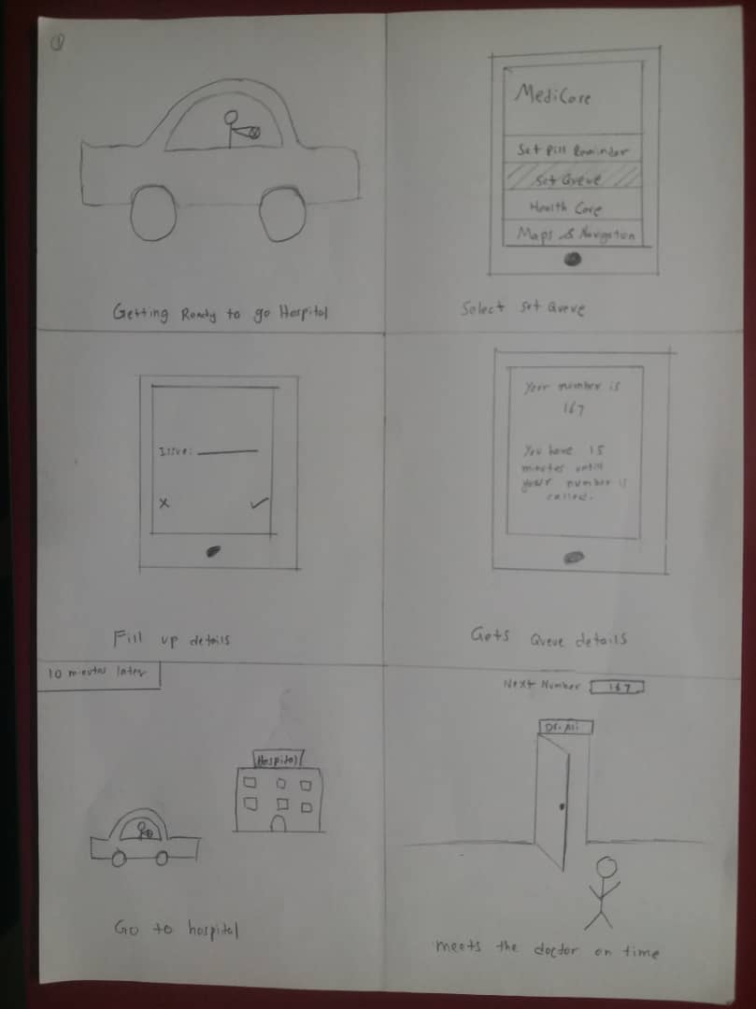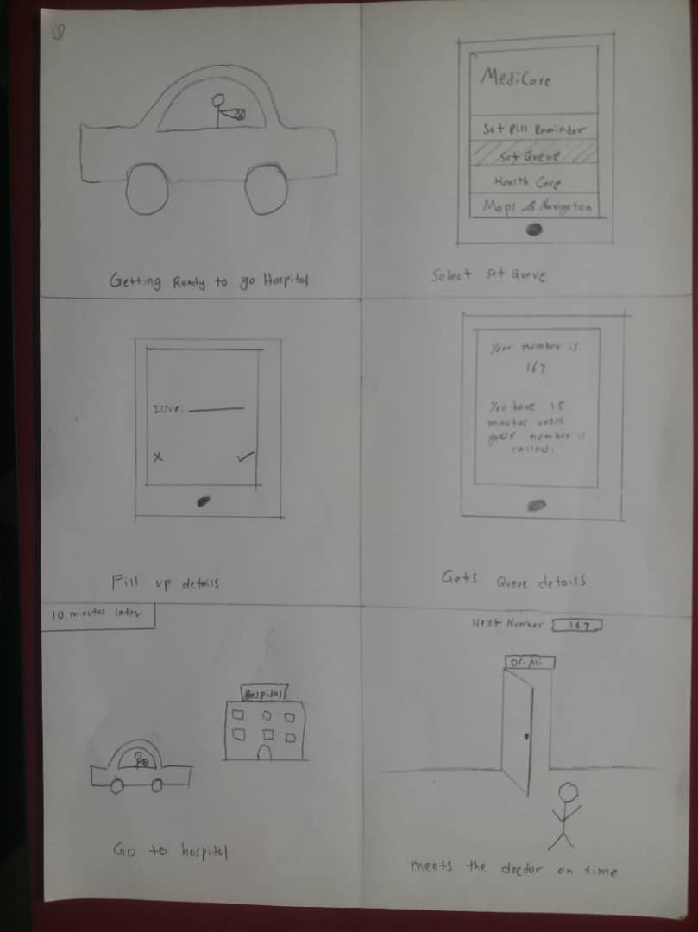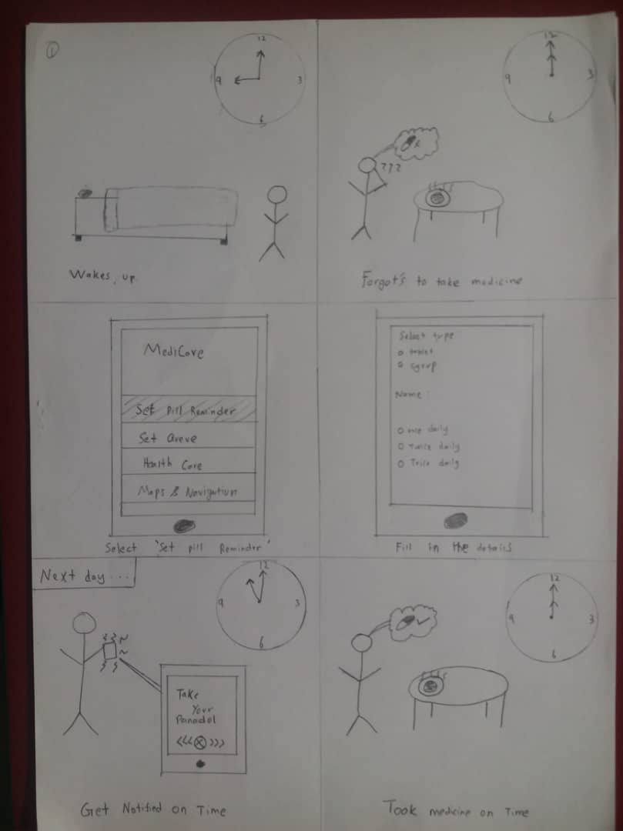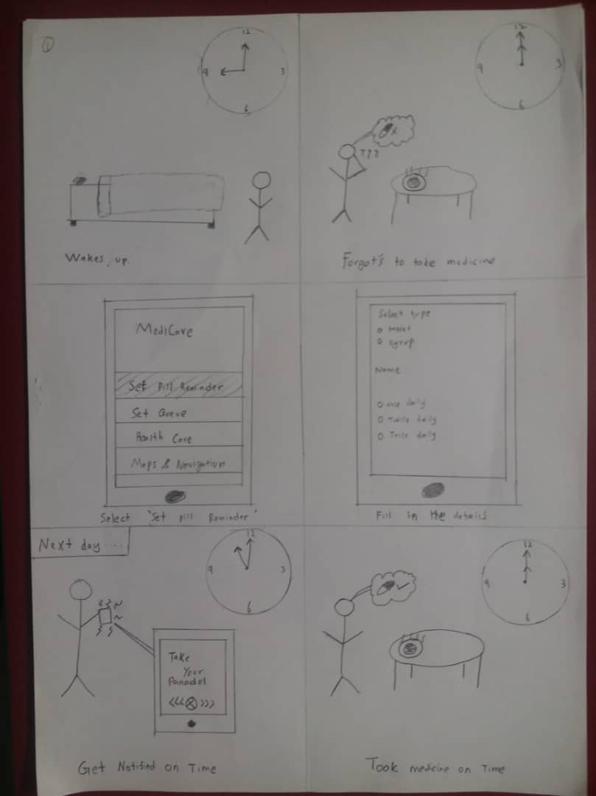

References
[1] Brade, M., Keck, M., Gr¨under, T., M¨uller, M., and Groh, R. Natural interface exploration. In Proc. of TEI ’13 , ACM (NY, USA, 2013), 427–430.
[2] Brade, M., Keck, M., Gr¨under, T., Kammer, D., and Groh, R. Exploring natural interaction: Using real-world materials to inspire interaction design. In ACM CHI - Workshop: Workshop: Blended Interaction - Envisioning Future Collaborative Interactive Spaces (Paris - France, 2013).
[3] Buxton, B. Surface and tangible computing, and the ”Small” matter of people and design. In Solid-State Circuits Conference, 2008. ISSCC 2008. Digest of Technical Papers. IEEE International (2008), 24–29.
[4] Charland, A., and Leroux, B. Mobile application development. Communications of the ACM 54, 5 (May 2011), 49.
[5] Freitag, G., Kammer, D., Tr¨ankner, M., Wacker, M., and Groh, R. Liquid: Library for interactive user interface development. In Mensch & Computer 2011: ¨uberMEDIEN|¨uBERmorgen, Oldenbourg Verlag (Chemnitz, 2011), 202–210.
[6] Hennecke, F., V¨olker, S., Schenk, M., Schaper, H., Borchers, J., and Butz, A. PerspectiveTable: blending physical and virtual collaborative workspaces. In In Proc. of ACM CHI Workshop on Blended Interaction: Envisioning Future Collaborative Interactive Spaces, ACM Press (Apr. 2013).
[7] Hosseini-Khayat, A., Seyed, T., Burns, C., and Maurer, F. Low-fidelity prototyping of gesture-based applications. In Proc. of EICS ’11, ACM (New York, NY, USA, 2011), 289294.
[8] Jacko, J. A., and Sears, A. Human-computer interaction: development process. CRC Press, 2009. [9] Kammer, D., Henkens, D., and Groh, R. GeForMTjs: a JavaScript library based on a domain specific language for multi-touch gestures. In ICWE 2012, Berlin, Germany, July 23-27, 2012. Proc. (2012), 444–447.
[10] Kammer, D., Wojdziak, J., Keck, M., Groh, R., and Taranko, S. Towards a formalization of multi-touch gestures. In Proc. of ACM ITS ’10, ACM (New York, NY, USA, Nov. 2010), 4958.
[11] Nebeling, M., and Norrie, M. jQMultiTouch: lightweight toolkit and development framework for multi-touch/multi-device web interfaces. In Proc. of EICS ’12, ACM (New York, NY, USA, 2012), 6170. [12] Zwicky, F. Discovery, Invention, Research Through the Morphological Approach, first american ed. MACMILLAN, 1969.

