

Assignment - 2

SCSV 2113
HUMAN COMPUTER INTERACTION

Submitted to :
NOR ANITA FAIROS BINTI ISMAIL
(Section 02)
Submitted By :
[Miraj Ahmed] [A16CS4017]
[Mohana Raj a/l Shanmugam] [A15CS0067]
[Nazmus Sakib] [A17CS0265]
[Wa’ad Shaher] [A17CS0288]

Dated: 12th November 2018

a.Most suitable interface of ATM for kids :
Kids are fast learner as well as curious to all the new things . Automated teller machine in short ATM , is being always a useful machine of human life. However as the time passes world seem to move forward thinking about making things easier, an ATM for kids will be one of those examples. As kids are growing on their heights , the actual machine will be unreachable for them. So we have to design the machine suitable for them. Keeping three main things in mind height, their needs and their day to day life behaviour , we can design an automated teller machine for kids.
So for height should be the average of an 8-14 years kids height. According to researches the average growth of kids to teenage is around 152 cm - 162 cm so the ideal height of the ATM should be around 155cm , so all can access and use.
Then comes the needs, kids are always fascinated by stuff that are simple yet attractive. That’s why they mostly seen buying candies, drinks, and other foods . so they might sometime be in need of small changes or even coins, if the ATM provides coin along with notes that would be very helpful for them.
And last but not least the behaviour, as we all know kids get carried away by many things. In the meantime they might forget about other stuff and it is very common for them. So if we design an ATM that does not require any card insertion and also secured , that would be something very beneficial for them.

b.The interface of the ATM :
An automated teller machine (ATM) is an electronic banking outlet that allows customers to complete basic transactions without the aid of a branch representative or teller. Anyone with a credit card or debit card can access most ATMs.
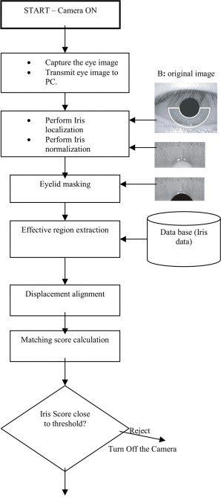
Access :
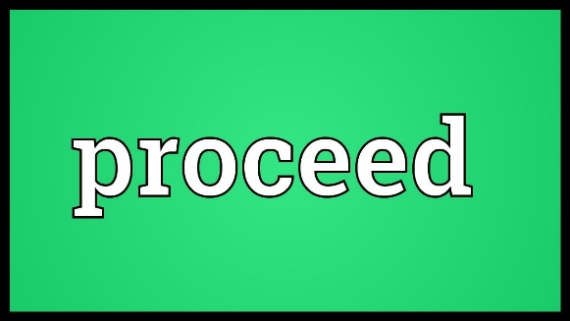
For accessing an account of a certain user, the machine will scan the Iris of the person standing in front of the machine. As we all know the human Iris carries a specific data for a specific person, so the matching would result in lesser false information as well as will be faster. In IRIS recognition, it uses video camera technology with subtle near infrared illumination to acquire images of the detail-rich, intricate structures of the iris which are visible externally. Digital templates encoded from these patterns by mathematical and statistical algorithms allow the identification of an individual or someone pretending to be that individual. Databases of enrolled templates are searched by matcher engines at speeds measured in the millions of templates per second per (single-core) CPU, and with remarkably low false match rates. So the user standing in front of the camera will be easily recognised whether the person is a kid or an adult. After that, as we mentioned earlier the iris scanning is so secured and specified that kids will not need to carry the card all the time to insert. It will work like bio metric scanning, as kids might forget or lose the card in day to day life .
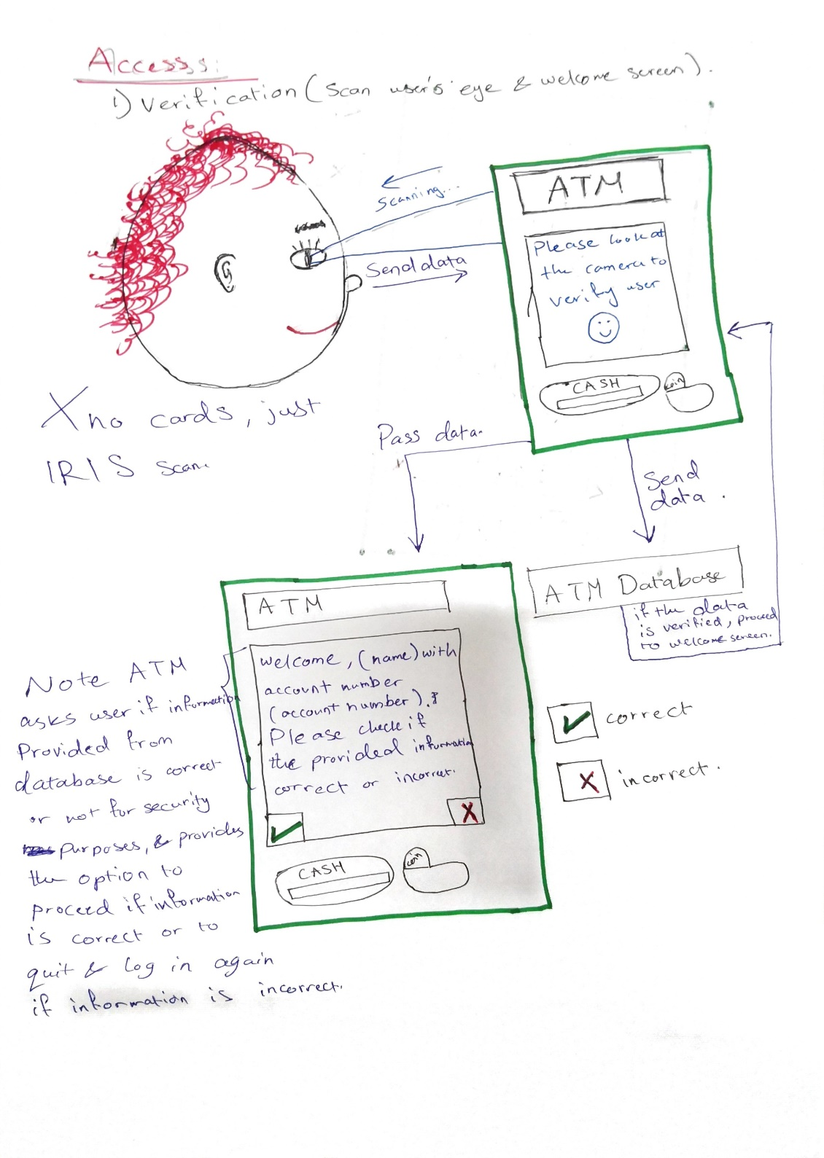

After getting the green sign to proceed , the kid will get few options in GIF. As we all know kids learn by watching, so the moving objects will be much easier and helpful to make them the task.

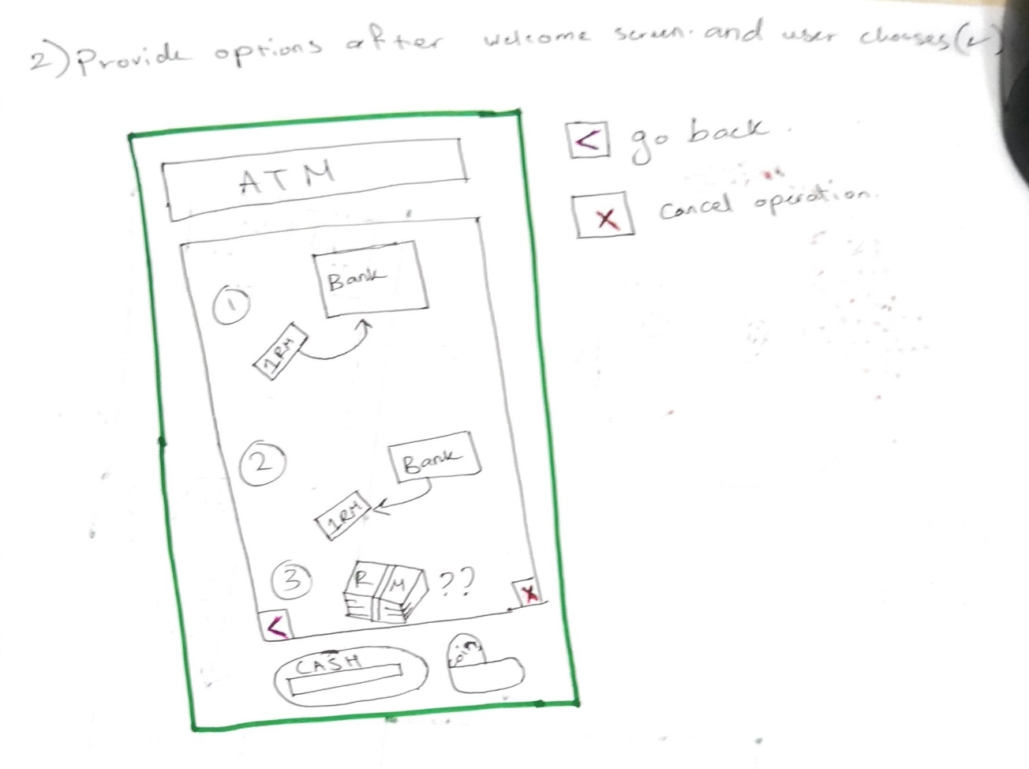
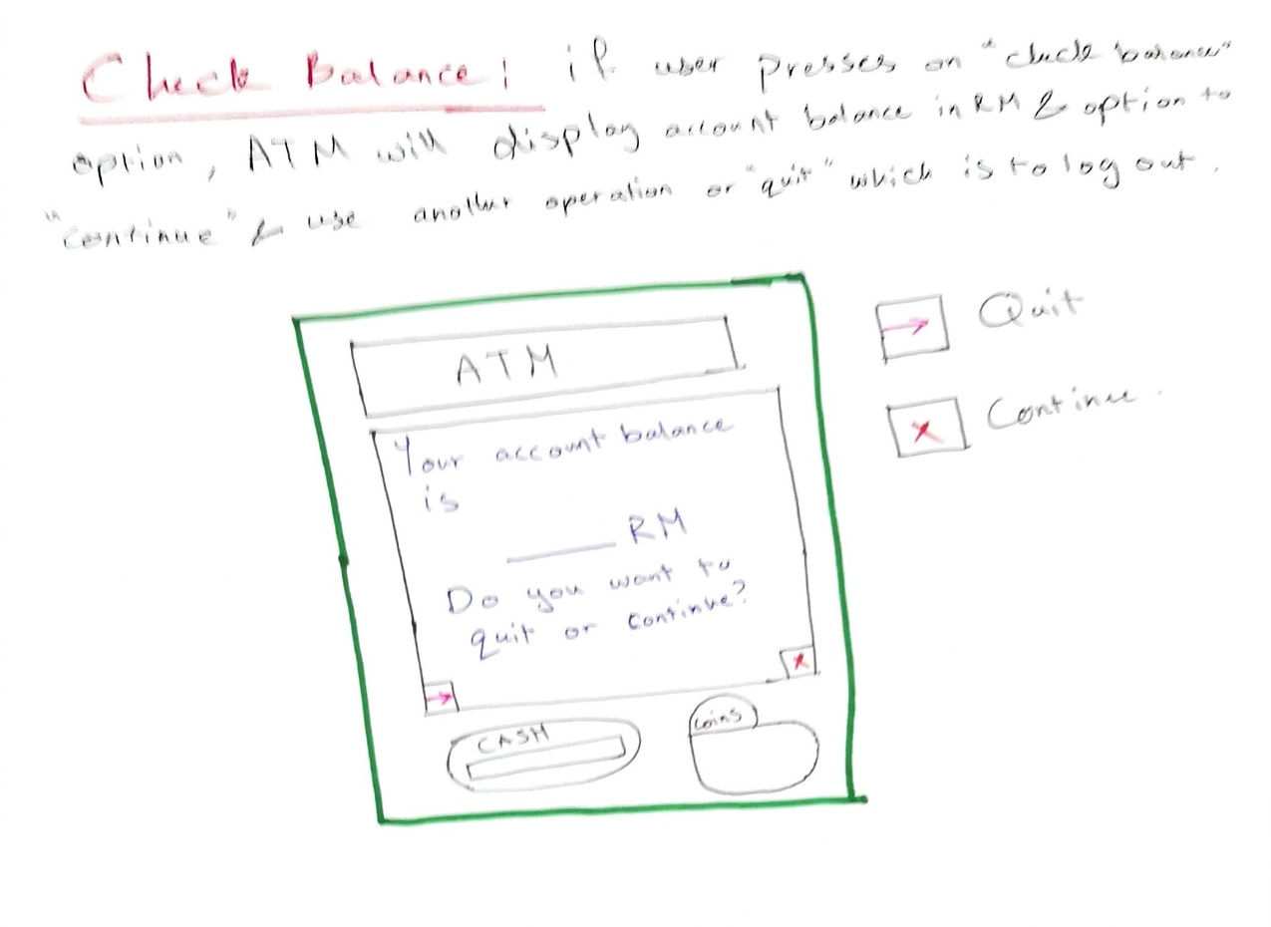
Check Balance : For check balance there will be a specific moving image which will let the kid know that this icon refers to check balance. After entering inside he/she will be able to check the balance.

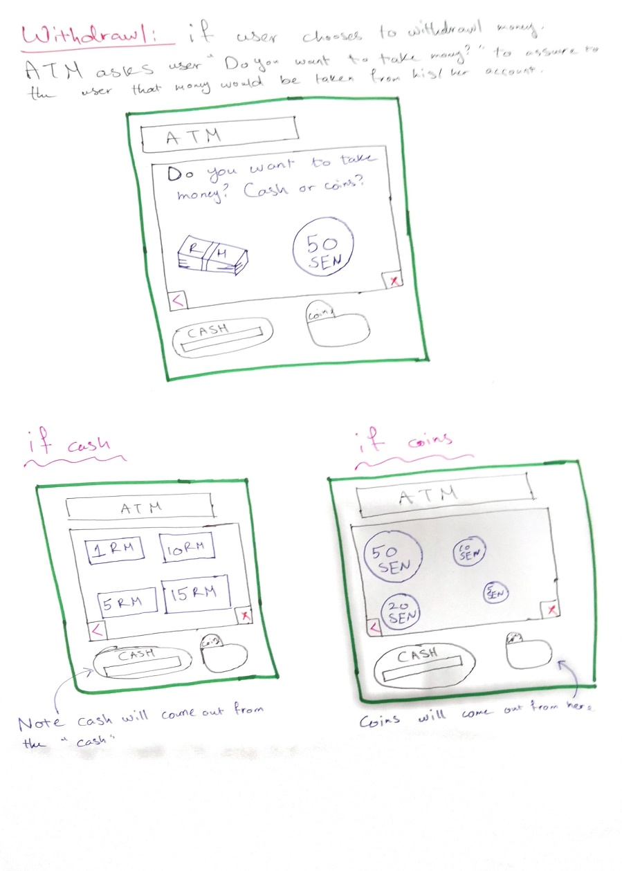
Withdraw : after entering the withdraw choice through the touch display , he/she is now wants to take out some money, as this machine is designed for kids, it will carry some fixed choices with a limit up to 15 RM per day. There will also be coin options, when the kid enters the choice , he will get an animation of coin or note, as kids prefer candies or drinks which requires coins to buy. So it will be very useful for him/her. Moreover the withdraw limit will teach him/her to spend less and think about the expenses , this will make a great moral value in the growing period of him/her.

c.Advantages and Disadvantages of the ATM :
Advantages
- High Security : Scanning the retina is one of the safest process in the world right now. Kids can forget their cards anywhere. So they can login their account with their retinal scan which is different for every person, and can also manage their transactions.
- Learnability : The graphical interface will help kids learn faster. They will show interest in using the interface. Which will help them learn faster on how to manage their transactions and save money.
- Easy to use : Kids might find using the ATM interface difficult. So the friendly environment can change the mind set of kids. This user friendly interface will attract more kids to use the machine.

Disadvantages
- Getting Robbed : Kids can get robbed as they just need to look at the camera for logging in. Elder people might force them to withdraw some cash.
- Wasting too much time : This graphical interface might make kids use the interface too many times, which will hamper their study time and time for other activities.

d.Suitable placement for the ATM :

The most suitable place for placing an ATM where kids are most often seen or they go, like cafeteria, school, shopping malls. In these places they feel the urge of using the best if his savings.

